Software Crisis :

To understand the present Software Crisis consider the following Facts. The Expense that organizations all over the world are incurring on software purchases have been showing an worrying trend over the years, As can be seen practically organizations are spending increasingly larger portion of their budget on software as compared to that of hardware. Almost all symptoms of present software crisis of increasing software costs is probably the most vexing.

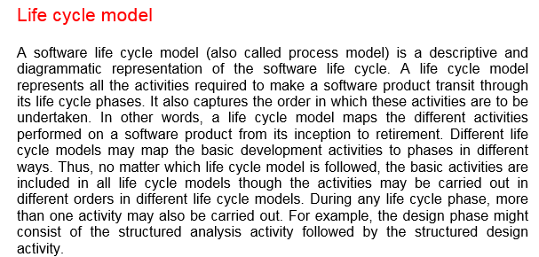

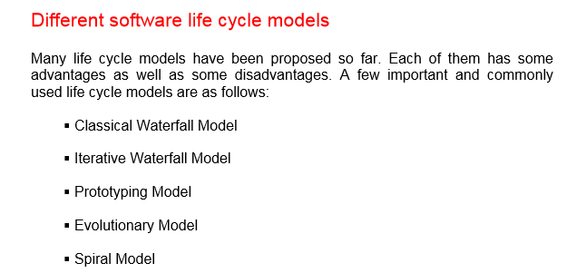

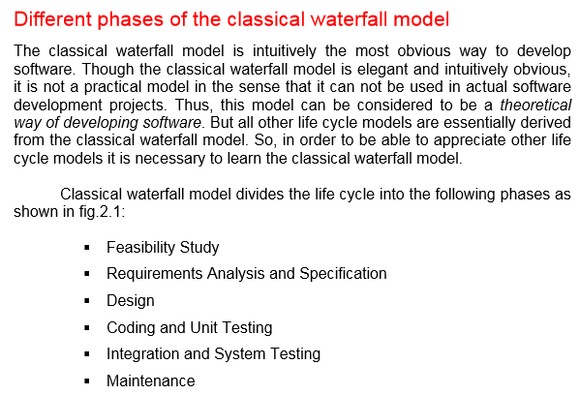

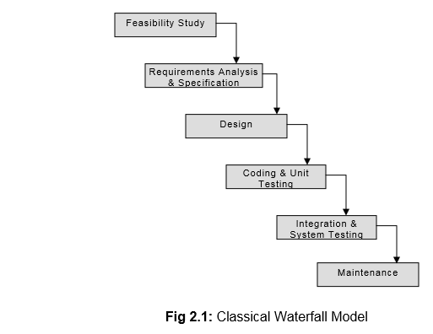

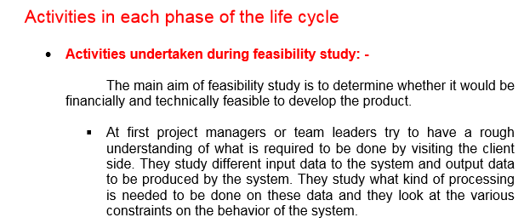

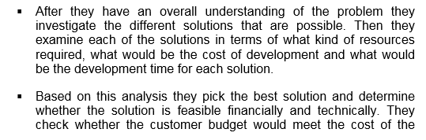
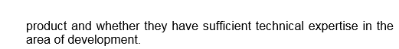

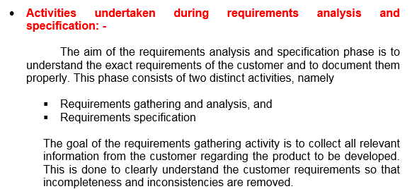
It is basically the preparation of SRS documen

The Requirement Gathering

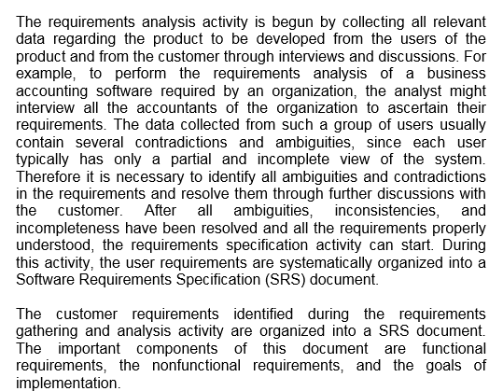

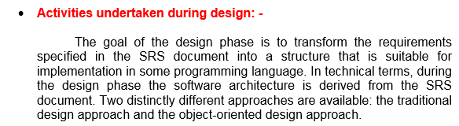

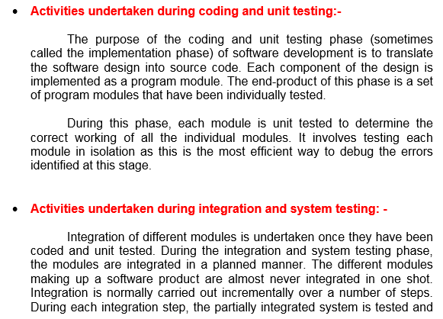
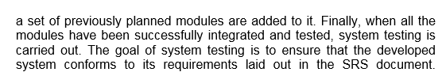

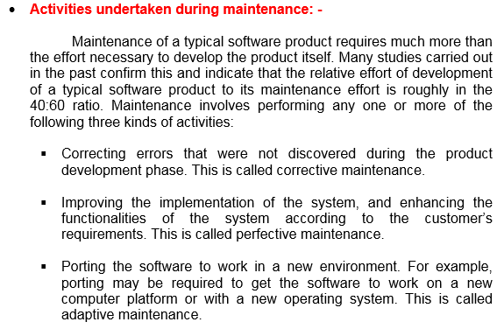

Problems with Waterfall Model

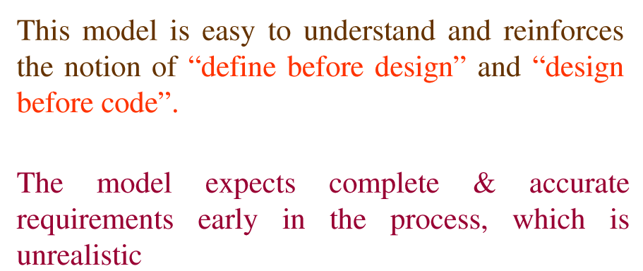

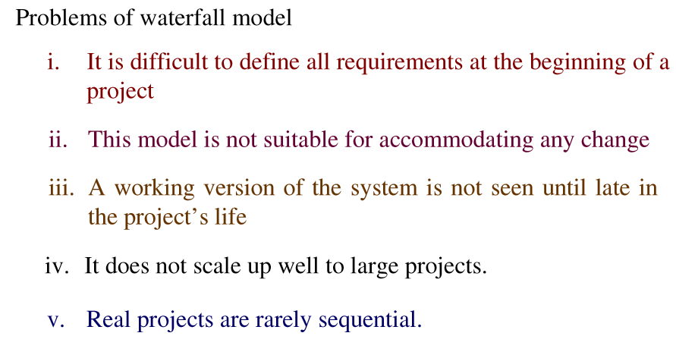

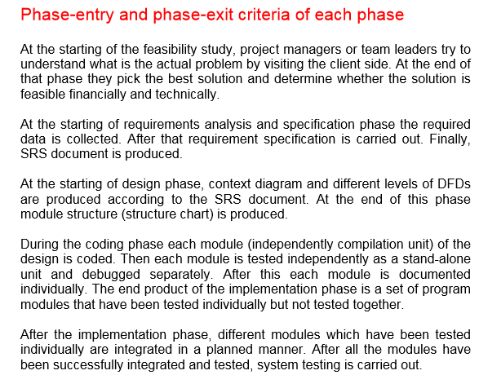

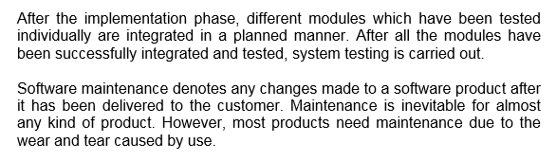

Iterative Water Fall Model:
Classical Waterfall model is an idealistic model.
The iterative water fall model can be thought of as incorporating the necessary changes to the classical waterfall model as an idealistic model.

The main change brought about by the iterative waterfall model to the classical waterfall model is in the form of providing feedback paths from every phase to its preceding phases.

The feedback paths allow for correcting errors committed by the programmer during some phase, as and when these are detected in a later phase.
If the error is detected in the testing phase then there is options to move to design phase and other subsequent phases , which was not allowed by the classical waterfall model.

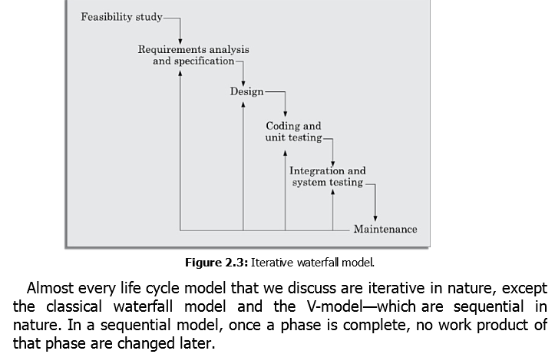

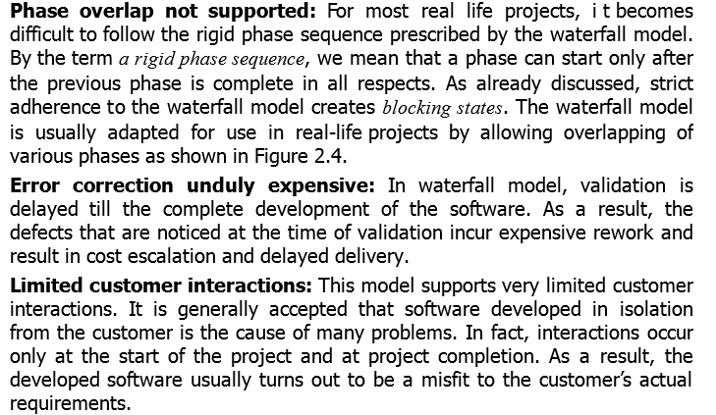
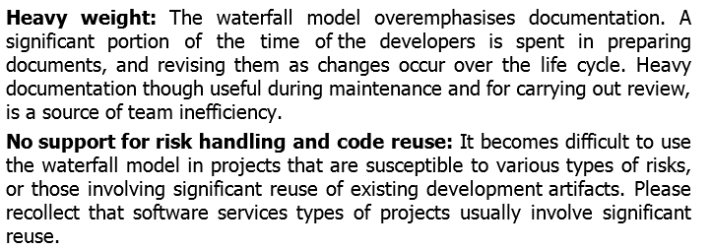

Validation : Customer end
Verification: Developer end

VMODEL :

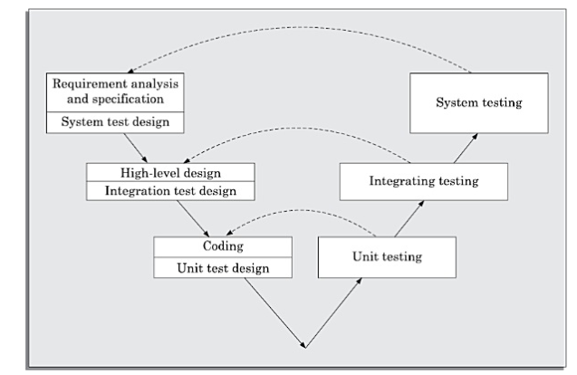

A popular development process model, V-model is a variant of the waterfall model.
In this model verification and validation activities are carried out throughout the development life cycle.
And there fore the chances of bugs in the development process considerably reduce.
Suitable for safety-critical and security purposed for its grater reliability.

Two phases:
Development & Validation phase
Left-half comprises development phase & right half is comprises validation phase.
In each development phase, along with the development of work product, test case design and plan for testing the work product is carried out.
In validation phase the testing is carried out in three steps:
Unit, Integration and system testing
Advantages :
Testing activities are carried out in parallel with the development activity. There fore before actual testing part occurs significant part of testing activities like test case design, test planning is done.
Schedule pressure has not been developed before so the quality of the test cases are usually better.
Test team is reasonably occupied throughout the development cycle. Efficient man power use.
Dis. Advantage: any type of software can not

Be developed always in model.
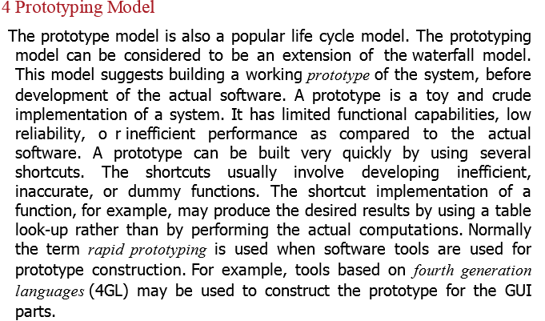

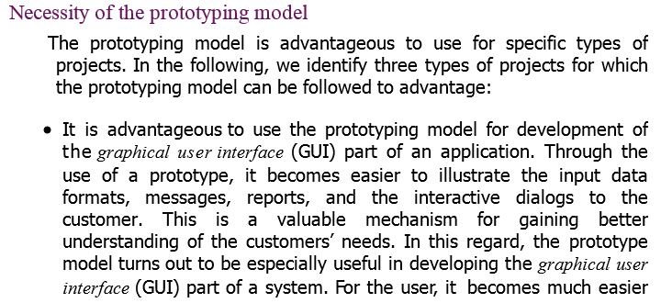
- Technical Solution are unclear to the development team.
- It is impossible to get the software right at first time. The prototyping model can be deployed when the development of highly optimised and efficient software is required.

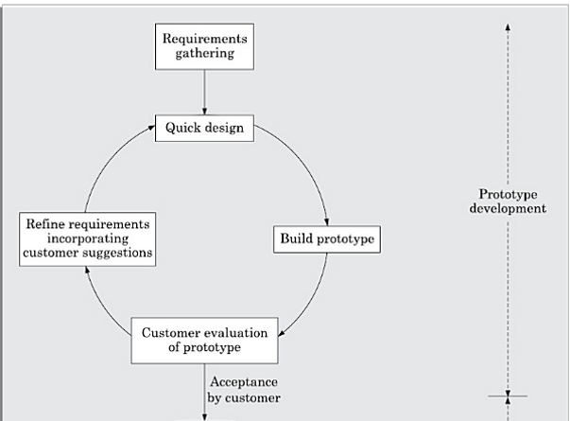

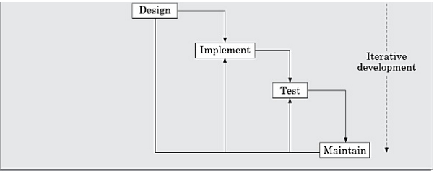

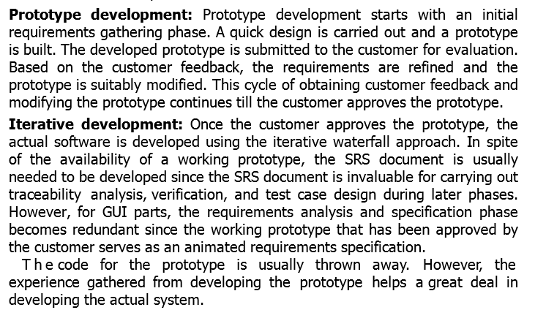

Risk in a software project is any anticipated unfavourable events or circumstances that can occur while a project is underway.
Risks are of various type:
Project Risk, Various forms budgetary, schedule, personnel, resource, customer-related problems.
Technical Risk: Design, implementation, interfacing, testing, maintenance
Business risk: developing an excellent product but no one wants it at appropriate cost.

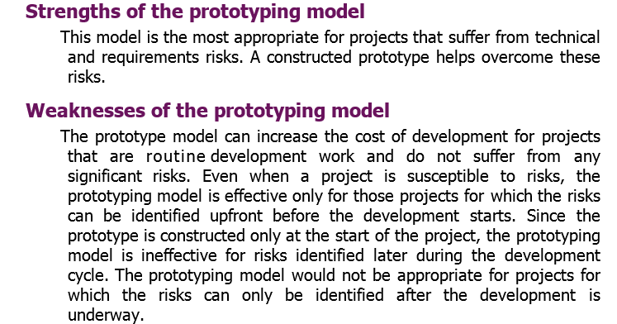
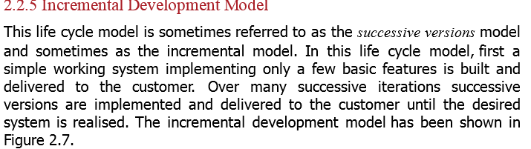

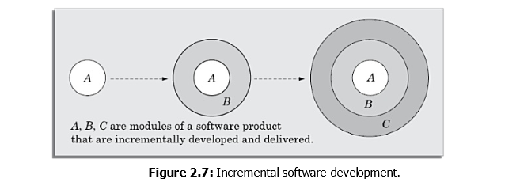
Successive versions Model / Incremental Model

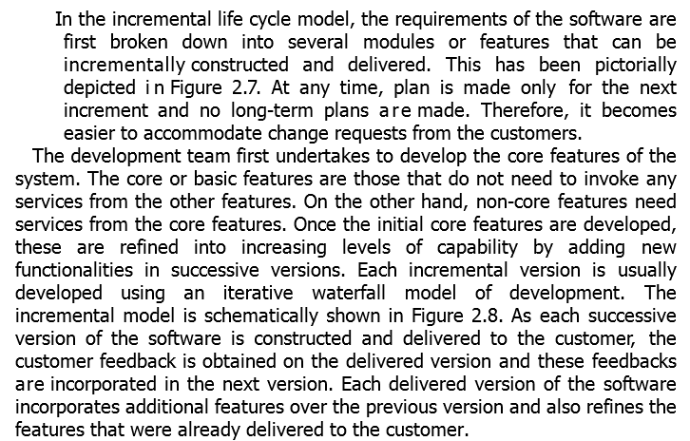

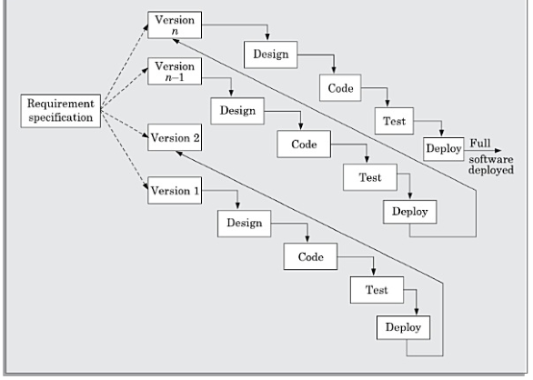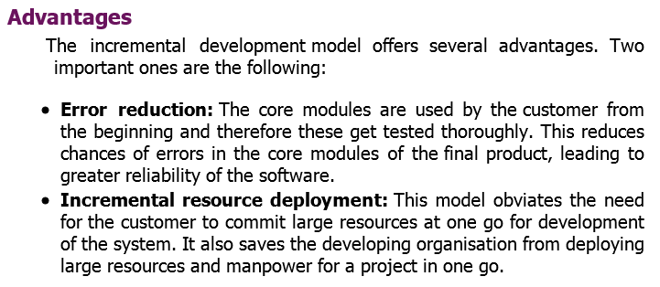

Disadvantage: This model is not applicable for small software. In every software it is difficult to find out the core model and divides whole software in various submodules. It is applicable for large projects.
Payroll: Core module (BASIC- pay )Dearness allowance (DA)HRAPPFTAX...
GUI that can not be

Evolutionary Model:

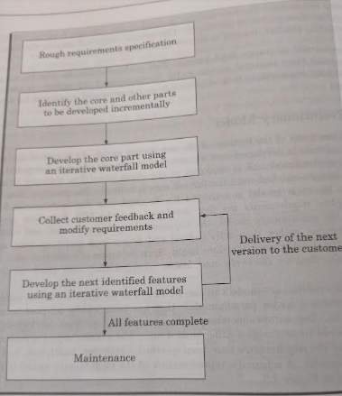

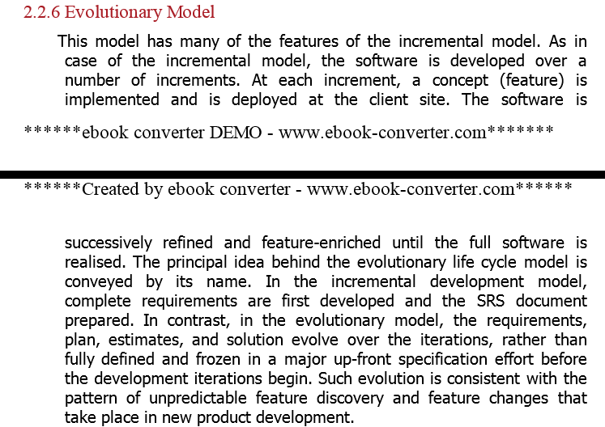

Evolutionary Model:

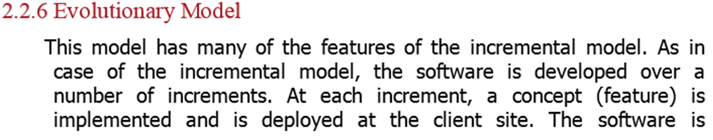
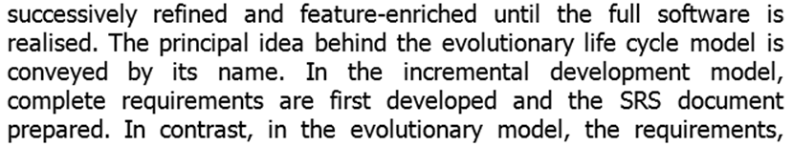
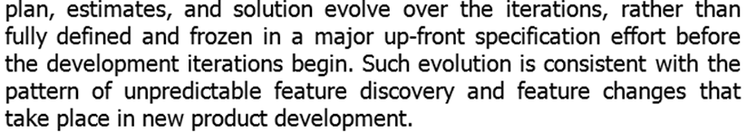
- Many of the features are like incremental model.
- As in case of incremental model the SW is developed over a number of increments or iterations.
- At each increment a concept is implemented and is deployed in the client site/ delivered to the client.
- The SW is successively refined and feature-enriched until the full SW is released.

- In incremental SW development model complete requirements are first developed and the SRS documents are prepared. In contrast, in evolutionary model the requirements , plan , estimates and solutions evolve over the iterations , rather than fully defined and frozen in a major-upfront specification effort before the development iteration begins.
- Due to obvious reasons the evolutionary model is referred as : design a little, build a little, deploy a little model.
- Well suited for object oriented SW development model. Easy to break down the project into various classes.

- ADV: users gets a chance to do experiment in the partially developed project much before the complete development is over. Change requests get reduced.
- Disadvantage
It is difficult to divide the required features into several parts that can be incrementally developed for all types of SW.

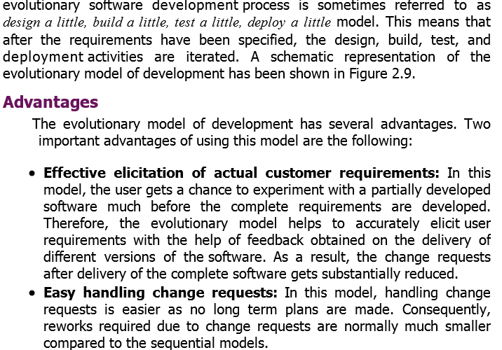

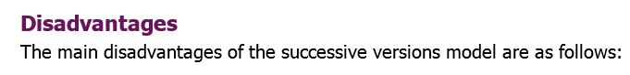
In many development project it is difficult to divide the total feature into several parts, mainly it becomes impossible for a small project.
RAD (Rapid Application Development)MODEL

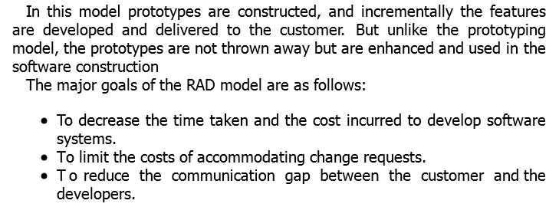

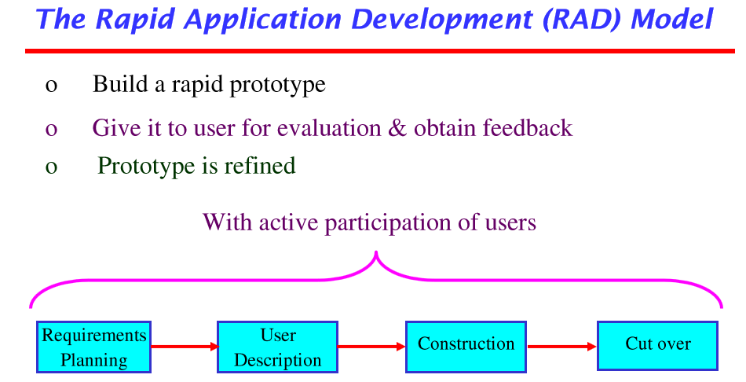

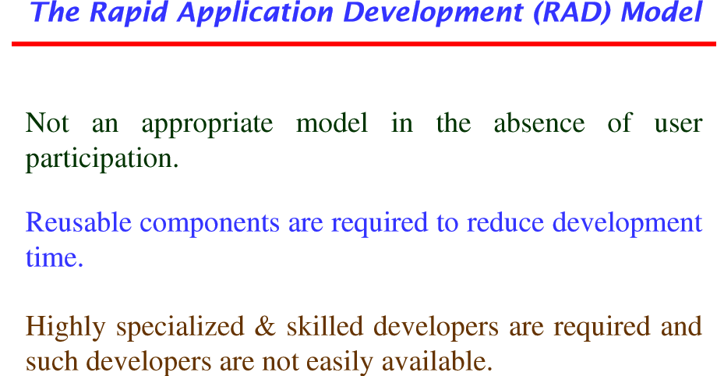

- Req. Planning phase: Requirements of the project are captured in active involvement of users for understanding the project.

- User description:
Joint teams of developer and user are constituted to prepare, understand and review the project.

- Construction phase : this phase combines detailed design coding, testing phases of waterfall model. The product is released to the customer.
- Cut over phase: This phase incorporate acceptance testing by users, installation of the system, users training.

Risk in a software project is any anticipated unfavourable events or circumstances
that can occur while a project is underway.
Project Manager needs to anticipate risks in a project as early as possible.
There are three main categories of Risks that may affect the project:
- Project Risks
- Technical Risks
- Business Risks

Project Risks: Budgetary, Schedule, Personnel, Resource and Customer related problem

Technical Risks : Potential Design, implementation, interfacing, testing and maintenance problems.

Business Risks: This type of Risks includes the risks of building an excellent product
that nobody wants.

- Risks are of various type:
- Project Risk,
- Various forms budgetary,
- schedule, personnel,
- resource,
- Customer-related problems.
- Important Project Schedule slippage.
Technical Risk: Concerns potential Design, implementation, interfacing, testing, maintenance problems. Due to the insufficient knowledge of the development team about the project.
Business risk: developing an excellent product but no one wants it at appropriate cost.

Exmp: Consider a satellite based mobile communication product. The project manager can Identify several risks
- If the project cost escalates and overshoots what was estimated; Project Risks
- Your mobile phone that has been developed is too bulky to carry. What type of project risk?
Business Risk
- Level radiation coming form it is much harmful?
Business risk.

- Project cost has escalates and overshoot what was estimated ? Project Risk
- If call hand-off between satellites becomes too difficult? Technical risk

Disaster Lists: This lists would contain all the bad events that have happened to the SW projects of the company over the years including events that can be laid at customer’s doors. Software manager should prepare and study it.

Risks Assessment: p=r*a
Priority of the risk, r is the prob of the risk, s is severity of the risks.
Mitigation of Risks
Avoid the risks
Transfer the Risks
Risk reduction

Spiral Model:
This model is completed with many loops. These loops are not fixed and varies from Project to Project.

This model is very much flexible. Main important feature of the spiral model is that it can incorporate RISK management process DIRECTLY.
While the prototype model does not provide explicit supports for risk handling, the risks are assumed to be identified completely before the project start. This required because the prototype is constructed before the start of the project.
In contrast, in the spiral model prototypes are built at the start of the every phase.
Each phase of the model is represented in a loop of spiral. In each loop one or more feature are incorporated and analyzed. At this time possibility of risks are identified and resolved through prototyping. Based on this, identified features are implemented.

Over each loop one or more features of the product are elaborated and analyzed and the risks at that point are identified and are resolved through prototyping. Based on these identified featured are implemented.

The Spiral model supports coping up with risks by providing the scope to build a prototype at every phase of software development.
Each phase in this model is split into four sectors or quadrants.

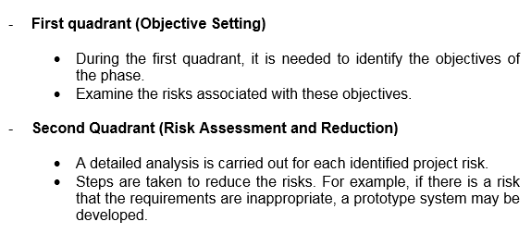

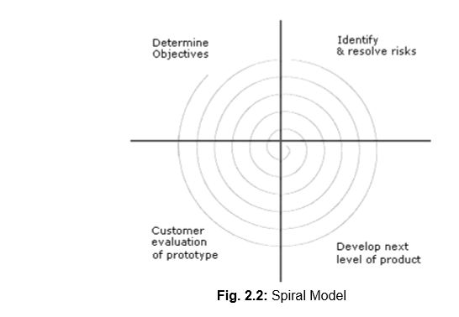

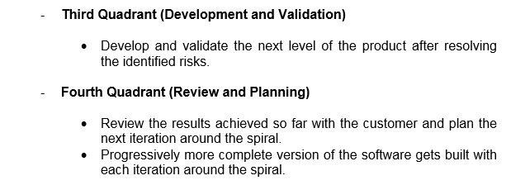

The radius of the spiral at any point represents the cost incurred in the project so far, and the angular dimension represents the progress made so far in the current phase.

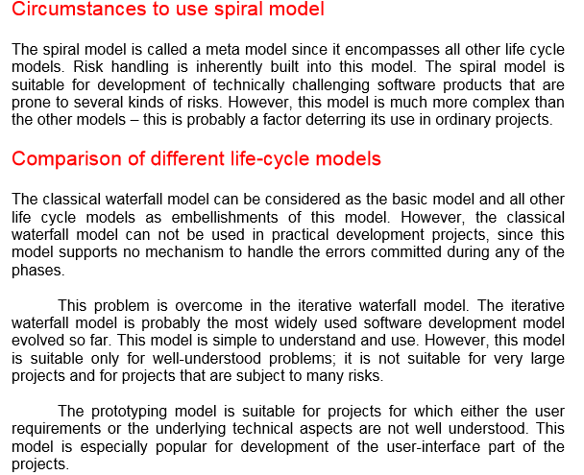
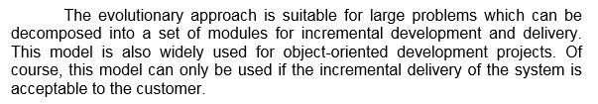
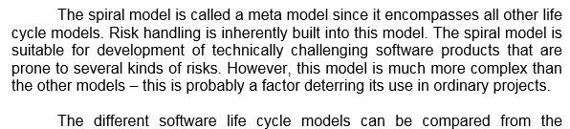
RAD (Rapid Application Development Model)
Here the user involvement is essential from requirement phase to delivery of the product. The continuous user participation ensures the involvement of user expectations and perspective in the requirement preparation, analysis and design of the project.
The process is started with building a rapid prototype and is given to the customer for evaluation. The customers feed feedback is obtained and prototypeis refined accordingly.
What is to be done is already defined.
View points of customers.

Spiral Model is Meta model :
- It is subsum of all discussed model.
- Single loop represents the classical waterfall model.
- Uses the approach of prototyping model first building prototype in each phase before the actual development stars. These prototypes are used as risk reduction mechanism
- The spiral model incorporates the systematic stepwise approach of waterfall model.
- It can be considered as supporting the evolutionary model. This model enables the developer to understand and resolve the risks at each evolutionary level.

The Selection of a Life Cycle model:
The selection of life cycle model is based on the following characteristics:
1. Requirements:
2. Development team
3. Users
4. Project type and associated Risks

Characteristics of requirements
There are numbers of situations and problems during requirements capturing and gathering
Requirements | Waterfall | Proto | Iterative | Evolu. | Spiral | RAD
Are requirements are easily understandable and defined? | Yes | NO | No | No | NO | Yes
Do you change req. Quite often? | No | Yes | No | no | Yes | Yes
Requirements are defined early in the life cycle? | Yes | No | Yes | Yes | No | Yes
Reqs. Are indicating that a complex reliable systems to be built. | NO | Yes | Yes | yes | Yes | NO

Development team
User involvement increases the understanding of the project and plays an important role in selection of appropriate model.
Development Team | Waterfall | Proto | Iterative | Evolu. | Spiral | RAD
Less experience in similar project | NO | Yes | No | No | Yes | No
Less domain knowledge (New to Tech) | No | NO | Yes | yes | Yes | No
Less experience in tools to be used. | Yes | No | No | No | Yes | NO
Availability of training, if required | No | No | yes | yes | No | Yes

Involvement of user
User involvement increases the understanding of the project and plays an important role in selection of appropriate model.
User involvement | Waterfall | Proto | Iterative | Evolu. | Spiral | RAD
User involvement in all phases | NO | Yes Best suited | No | No | Yes | Yes
Limited user participations | Yes | NO | Yes | yes | Yes | No
User has no experience in participation | NO | Yes | Yes | yes | Yes | NO
Users have experience in problem domain | Yes | No | - | - | Yes | Yes

Type of Project and Associated Risks. Project type is also important for the selection of a model.
Project Type and Risks | Waterfall | Proto | Iterative | Evolu. | Spiral | RAD
Project is the enhancement of Existing system | NO | No | Yes | No | Yes | Yes
Funding is stable for the project | Yes | Yes | No | No | Yes | Yes
High reliability requirement | NO | No | Yes | yes | Yes | NO
Tight Project schedule( BS?) | No | yes | Yes | Yes | Yes | Yes
Use reusable components | No | Yes | No | No | Yes | Yes
Are resources scarce? | No | Yes | No | No | Yes | No

- A software is required with fixed cost and within fixed schedule Which is best suited ??

Prototype is best suited, then iterative.

- Developer has less experience in the field: Prototype BS, Spiral
Selection Based on user participation

Development team | WFM | Proto | Iterative | Evo | spiral | RAD
User involvement in all phases | No | Y | - | - | y | y
Limited user participation | yes | N | N | N | y | Yes
User has no experience in participation in similar proj | N | yes |  |  |  | N
Users are experts of problem domain | No | yes | yes | Yes | No | Yes

Selection of model based on the type project and associated risks
Project type and risks | WFM | Proto | Iterative | Evo | Spiral | RAD
The is the enhancement  Of an existing project |  |  | Yes | Yes
Funding is stable for the project | yes | Yes |  |  |  | Yes
HIGHLY RELIABLE REQUIREMENTS | No | YES | YES | YES | YES | No
Tight project schd. | No | Yes  BS |  | yes | Yes | Yes BS
Use of re useable components | No
Are resources (time money people etc,) scarce?

